**FSDA assignment-1**

Task-1

>create or replace table shopping_history(

product varchar(100) not null,

quantity integer not null,

unit_price integer not null

);

>drop table shopping_history;

>insert into shopping_history values ('milk',3,10),('bread',7,3),('bread',5,2),('chocolates',5,10),('chips',5,20),('chips',2,30),('bread',2,30),('milk',2,50),('butter',2,90),('dahi',1,70);

>select * from "INEURON"."PUBLIC"."SHOPPING_HISTORY";

**>select product, sum(unit_price*quantity) as total_price from "INEURON"."PUBLIC"."SHOPPING_HISTORY" group by product order by product desc ;**

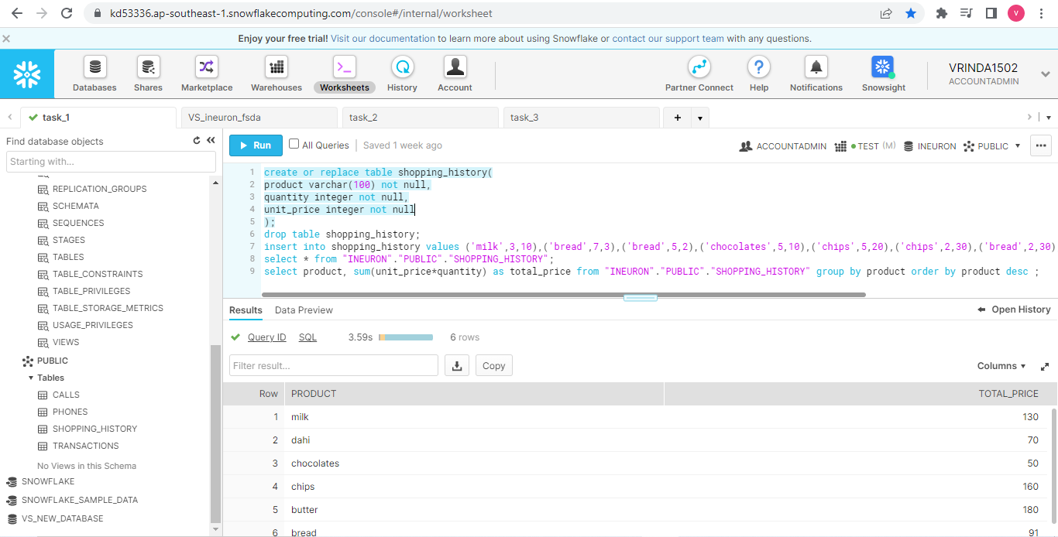

Task-2

>create or replace table phones(

name varchar(20) unique not null,

phone_number number(4,0) unique not null);

>create or replace table calls(

id number(7,0) not null,

caller number(4,0) not null,

callee number(4,0) not null,

duration number(3,0) not null,

unique(id));

--question 1

>insert into phones values ('Jack',1234),('Lena',3333),('Mark',9999),('Anna',7582);

>select * from "INEURON"."PUBLIC"."PHONES";

>insert into calls values (25,1234,7582,8),(7,9999,7582,1),(18,9999,3333,4),(2,7582,3333,3),(3,3333,1234,1),(21,3333,1234,1);

>select * from "INEURON"."PUBLIC"."CALLS";

>**select name from(select p.phone_number,p.name,sum(c.duration) as durations from phones p left outer join calls c on p.phone_number = c.caller or p.phone_number = c.callee where c.caller<>c.callee group by p.phone_number,p.name) where durations >=10 order by name;**

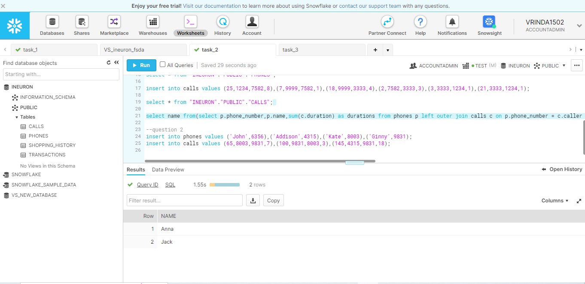

--question 2

>insert into phones values ('John',6356),('Addison',4315),('Kate',8003),('Ginny',9831);

>insert into calls values (65,8003,9831,7),(100,9831,8003,3),(145,4315,9831,18);

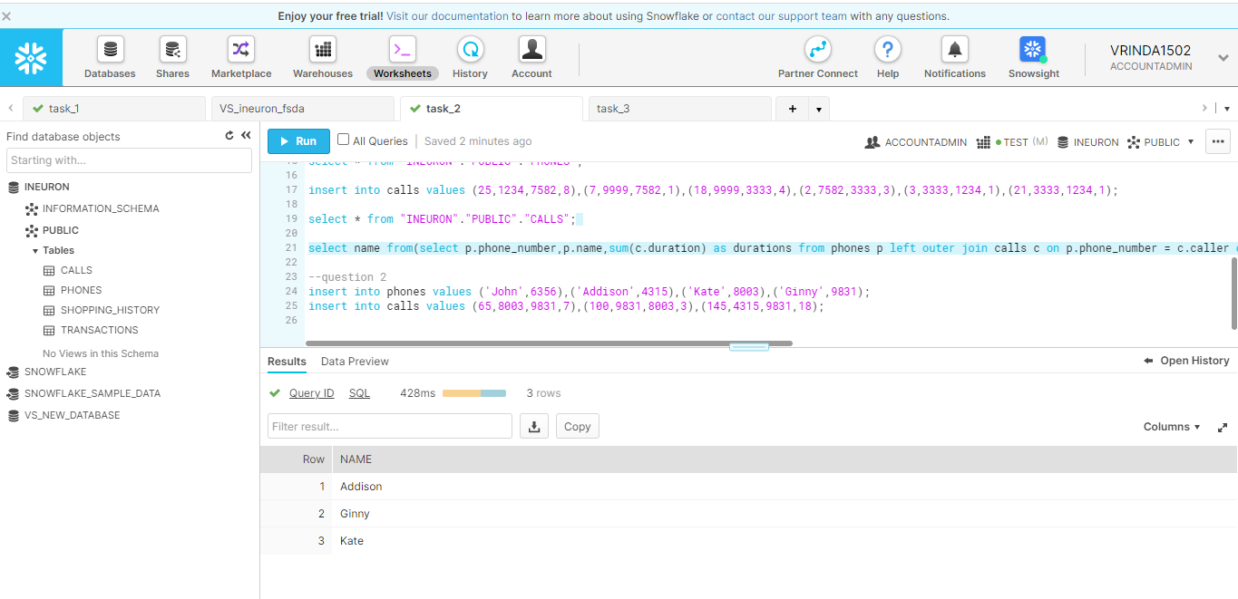

Task -3

>create or replace table transactions(

Amount integer not null,

Date date not null);

>drop table transactions;

--question 1

>insert into transactions values (1000,'2020-01-06'),(-10,'2020-01-14'),(-75,'2020-01-20'),(-5,'2020-01-25'),(-4,'2020-01-29'),(2000,'2020-03-10'),(-75,'2020-03-12'),(-20,'2020-03-15'),(40,'2020-03-15'),(-50,'2020-03-17'),(200,'2020-10-10'),(-200,'2020-10-10');

--select sum(amount) from "INEURON"."PUBLIC"."TRANSACTIONS";

--select *,sum(amount) over(partition by month(date)) as sum_amount, count(amount) over(partition by month(date)) as count_amount from transactions where amount<0);

--select month(date) as month,sum(amount) as sum_amount,count(amount)as count_amount from "INEURON"."PUBLIC"."TRANSACTIONS" where amount<0 group by month(date);

**>select (sum(amount)-(select (12-count(*))*5 from (select sum(amount),count(*) from "INEURON"."PUBLIC"."TRANSACTIONS" where amount<0 group by month(date) having count(*)>=3 and sum(amount)<=-100)))as balance from "INEURON"."PUBLIC"."TRANSACTIONS";**

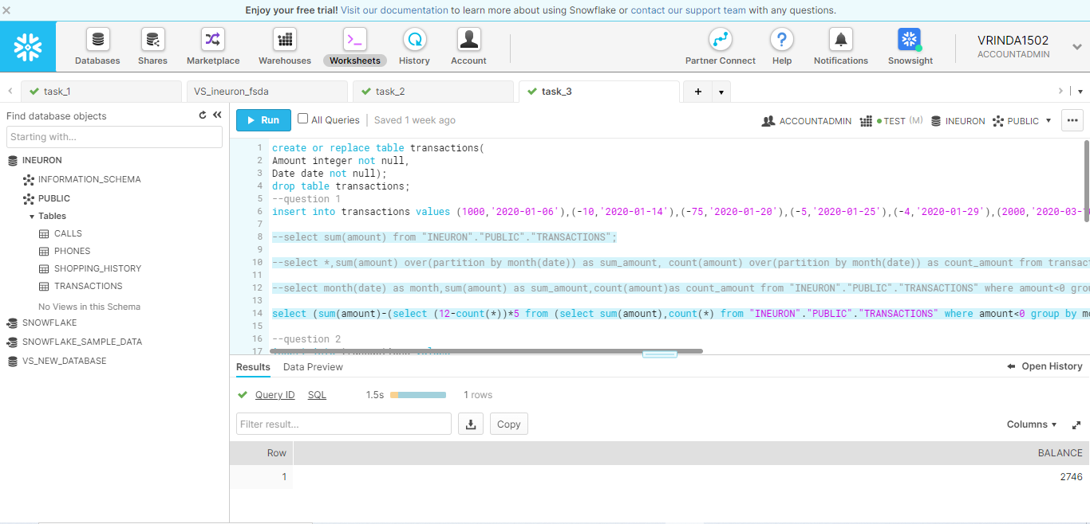

--question 2

>insert into transactions values

(1,'2020-06-29'),

(35,'2020-02-20'),

(-50,'2020-02-03'),

(-1,'2020-02-26'),

(-200,'2020-08-01'),

(-44,'2020-02-07'),

(-5,'2020-02-25'),

(1,'2020-06-29'),

(1,'2020-06-29'),

(-100,'2020-12-29'),

(-100,'2020-12-30'),

(-100,'2020-12-31');

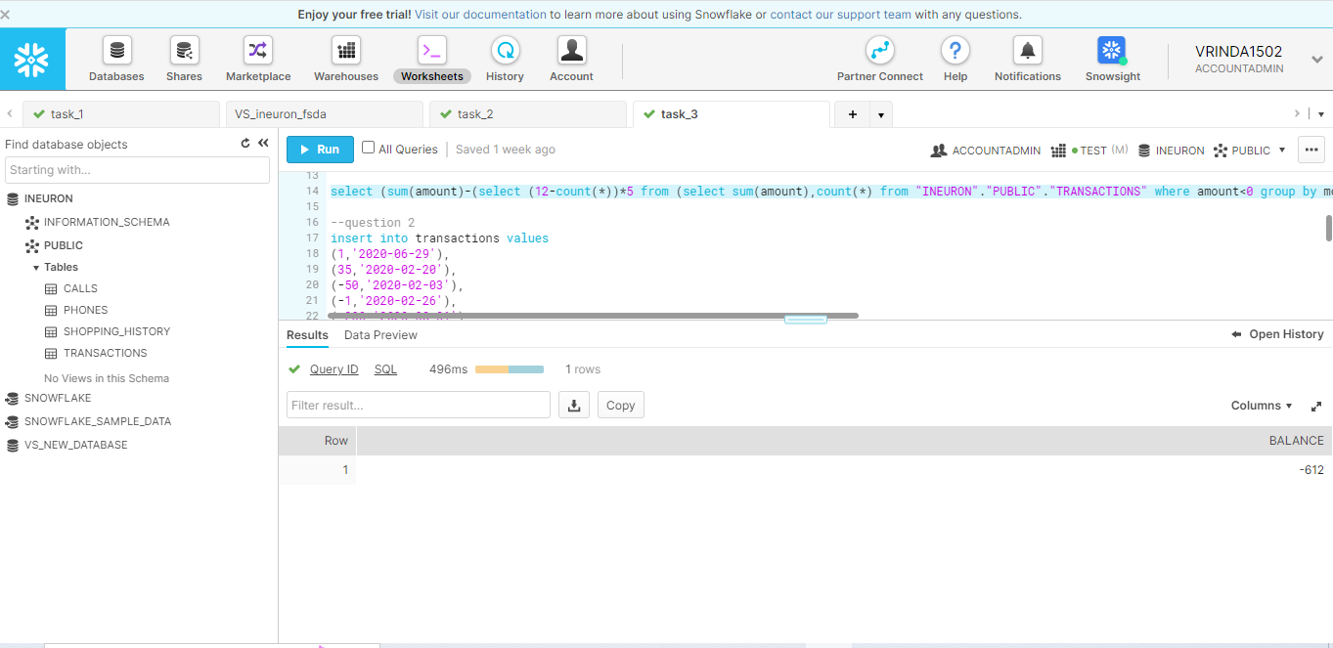

--question 3

>insert into transactions values

(6000,'2020-04-03'),

(5000,'2020-04-02'),

(4000,'2020-04-01'),

(3000,'2020-03-01'),

(2000,'2020-02-01'),

(1000,'2020-01-01');

